Qualcomm
Change request
- Partial Receiving


Change Request
Partial Receiving

Purpose of document

This document is to layout the change request detail and mean for the IT change in the WMS Hub and Exceed.

Version Info
Version | Revision Date | Revision Description | Author
1.0 | 2011 05 05 | First Draft | Dennis Low

Location of Document

Table of Contents

1. Background Information 5
2. Overview of Change 5
3. Inbound – 3B2 5
4. Printing of ITS 5
5. RF receiving Screen 5
6. Exceed – ASN Screen 5
7. Finalize of the ASN in Hub 5
8. Reports 6
8.1. Qualcomm – Outstanding Inbound 6
8.2 Qualcomm – Expected Inbound 6
9. 4B2 Generation 6
10. Nightly Auto Finalize Job 7
11. Questions 7

Change Request

Background Information
Due to change in the business rule as Qualcomm wanted to perform partial receipt in order to urgently ship out the inventory before completion of receipt of whole ASN. Changes need to be done in both Oracle (Qualcomm) and Exceed (Schenker).

Overview of Change

The change is to allow Schenker WMS to perform partially receiving on the ASN/3B2.
Currently, there isn’t partial receiving is allow in WMS due to the business set up.

Refer to the functional specification from Qualcomm IT below;

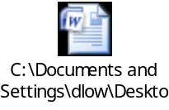

.

Inbound – 3B2

No changes to the inbound 3B2 import into WMS..

Printing of ITS

No changes to the ITS printing.

RF receiving Screen

No changes to RF receiving in the RF guy.

Exceed – ASN Screen

Operation will continue enter hawb#....etc from Exceed, but no perform of finalized of ASN in Exceed.

Finalize of the ASN in Hub

In the Exceed, currently ops can only perform finalize of the ASN when only total ASN expected qty same as total qty received. Hence no way that ops can perform partial receiving in Exceed. Therefore, new finalize screen will be built in the hub to allow ops to perform partial finalize of receipt.

In this new screen, ops will retrieve by entering WMS receiptkey or ASN number. After ops entered the receiptkey, new screen will only display those LPs that already received into WMS BUT have not send 4B2 to Qualcomm (receipt line # not found in transmitlog table for same receiptkey). Ops just need to click on <Finalize ASN> to close the lines and system will send 4B2 to Qualcomm.

Sample of the screen below, we need fields : Schenker ASN, Schenker ASN line #, Pakcslip# (externreceiptkey), Packslip line# (externlinenumber), SKU, LP#, Qty received.

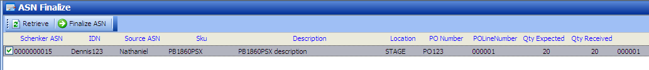

Reports
In the WMS, below as few reports that need to changes;

8.1. Qualcomm – Outstanding Inbound

To include qty received and status in the report;
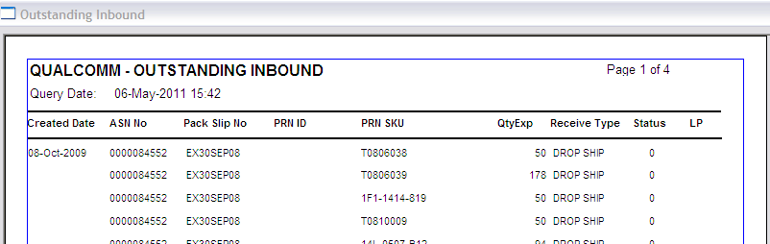

8.2 Qualcomm – Expected Inbound

To include qty received and status in the report;
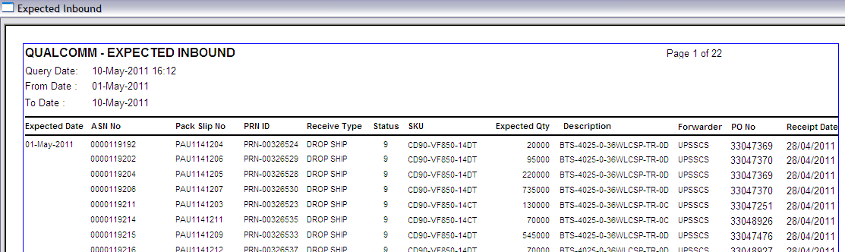

4B2 Generation

Need to remove current validation rule that set during 4B2 generation. Current validation on total qty expected must be same as total qty received is no more valid. It will be removed during 4B2 generation.

Nightly Auto Finalize Job

There is schedule nightly job that set up to help ops to auto finalize the ASN that already receipt. Selection condition for this job will change to only select those those LPs that already received into WMS BUT have not send 4B2 to Qualcomm (receipt line # not found in transmitlog table for same receiptkey).

Questions
- How to prevent ops over receipt ? any check on ops over receipt by accident?
- To be determined

